Name: Saurabh Kadam

Roll No.: 47

Course: PGDACC (ESDS)

Subject: DBA

Assignment No. 1

**Title**: MySQL Installation on Windows and Linux

**Aim**: Installation and Configuration of MySQL on Windows and Linux

* MySQL Windows Installation
* MySQL Windows’s configuration
* MySQL Linux Installation
* MySQL Linux configuration
* Database manipulation with putty

**Theory:**

1. **Database:**

A database is a separate application that stores a collection of data. Each database has one or more distinct APIs for creating, accessing, managing, searching and replicating the data it holds. Other kinds of data stores can also be used, such as files on the file system or large hash tables in memory but data fetching and writing would not be so fast and easy with those type of systems.

1. **MySQL**:-

MySQL is the most popular Open Source Relational SQL Database Management System. MySQL is one of the best RDBMS being used for developing various web-based software applications. MySQL is developed, marketed and supported by MySQL AB, which is a Swedish company. This tutorial will give you a quick start to MySQL and make you comfortable with MySQL programming.

1. **MySQL Database**

MySQL is a fast, easy-to-use RDBMS being used for many small and big businesses. MySQL is developed, marketed and supported by MySQL AB, which is a Swedish company. MySQL is becoming so popular because of many good reasons −

* MySQL is released under an open-source license. So you have nothing to pay to use it.
* MySQL is a very powerful program in its own right. It handles a large subset of the functionality of the most expensive and powerful database packages.
* MySQL uses a standard form of the well-known SQL data language.
* MySQL works on many operating systems and with many languages including PHP, PERL, C, C++, JAVA, etc.
* MySQL works very quickly and works well even with large data sets.
* MySQL is very friendly to PHP, the most appreciated language for web development.
* MySQL supports large databases, up to 50 million rows or more in a table. The default file size limit for a table is 4GB, but you can increase this (if your operating system can handle it) to a theoretical limit of 8 million terabytes (TB).
* MySQL is customizable. The open-source GPL license allows programmers to modify the MySQL software to fit their own specific environments.

1. **Installation Steps of MySQL on Windows:-**

Download MySQL Installer

If you want to install MySQL on the Windows environment, using MySQL installer is the easiest way. MySQL installer provides you with an easy-to-use wizard that helps you to install MySQL with the following components:

* MySQL Server
* All Available Connectors
* MySQL Workbench with Sample Data Models
* MySQL Notifier
* Tools for Excel and Microsoft Visual Studio
* MySQL Sample Databases
* MySQL Documentation

To download MySQL installer, go to the following link <http://dev.mysql.com/downloads/installer/>.  There are two installer files:

If you are connecting to the internet while installing MySQL, you can choose the online installation version  mysql-installer-web-community-<version>.exe .

In case you want to install MySQL offline, you can download the  mysql-installer-community-<version>.exe  file.

Install MySQL via MySQL Installer

To install MySQL using the MySQL installer, double-click on the MySQL installer file and follow the steps below:

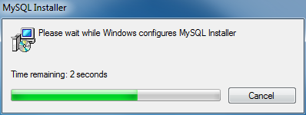

**Install MySQL Step 1: Windows configures MySQL :-**

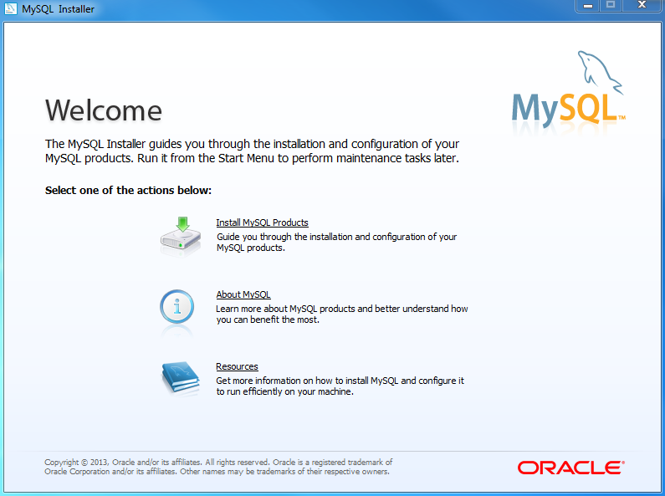

**Step 2 – Welcome Screen: A welcome screen provides several options. Choose the first option: Install MySQL Products**

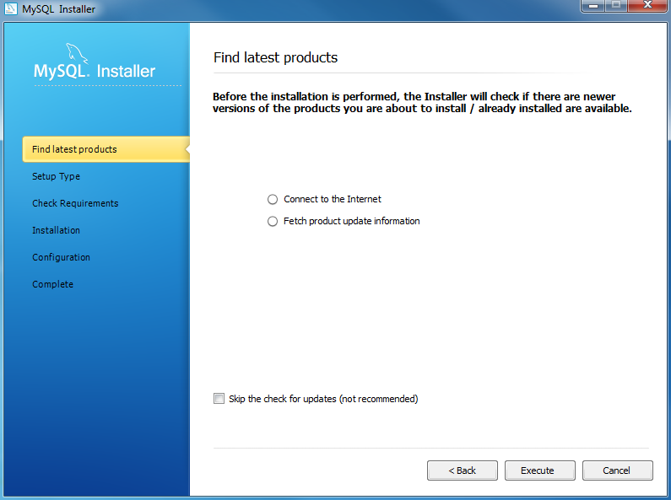

**Step 3 – Download the latest MySQL products: MySQL installer checks and downloads the latest MySQL products including MySQL server, MySQL Workbench, etc.**

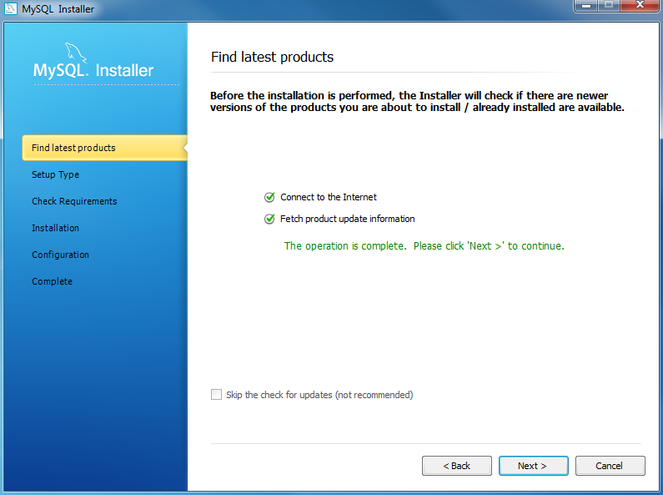

**Step 4: Click the Next button to continue**

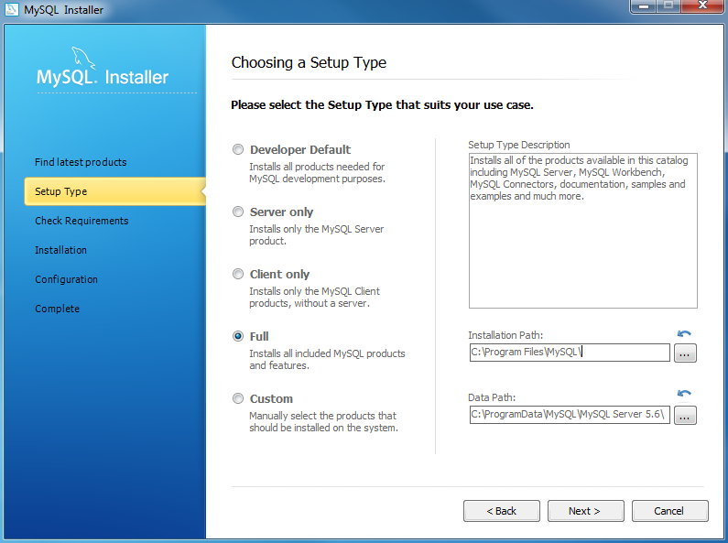

**Step 5 – Choosing a Setup Type: there are several setup types available. Choose the Full option to install all MySQL products and features.**

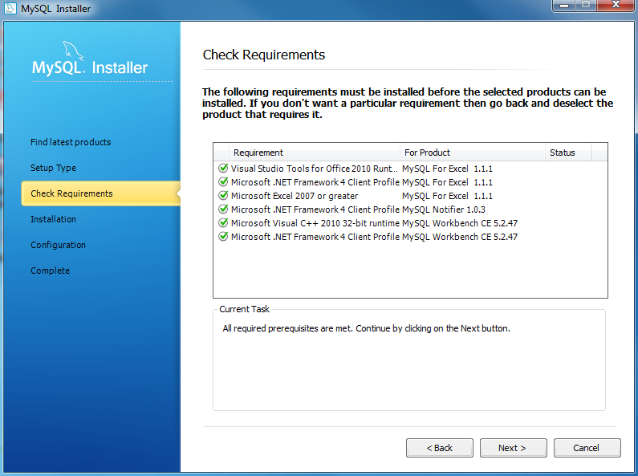

**Step 6 – Checking Requirements**

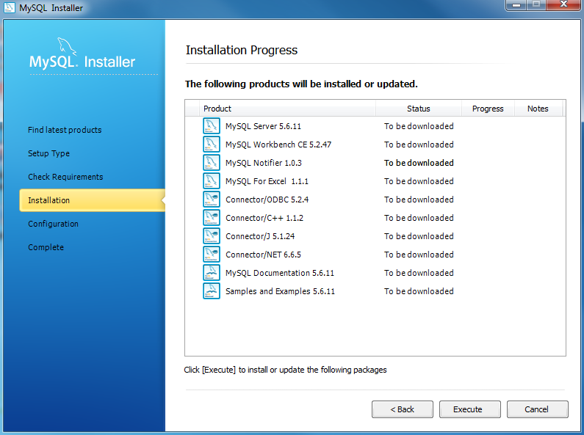

**Step 7 – Installation Progress: MySQL Installer downloads all selected products. It will take a while, depending on which products you selected and the speed of your internet connection.**

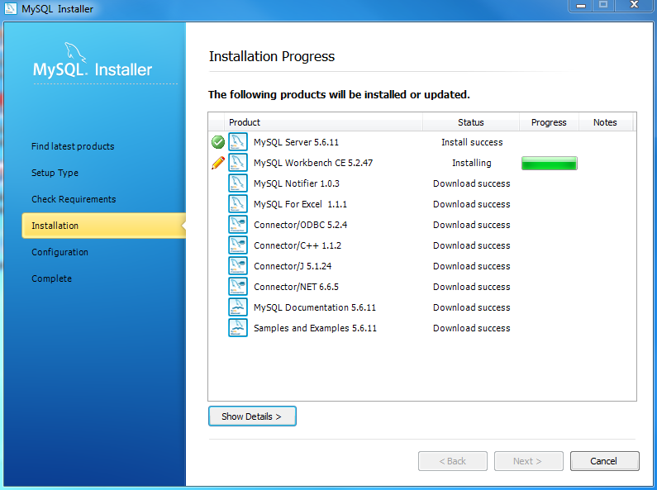

**Step 7(A) – Installation Progress: downloading Products in progress.**

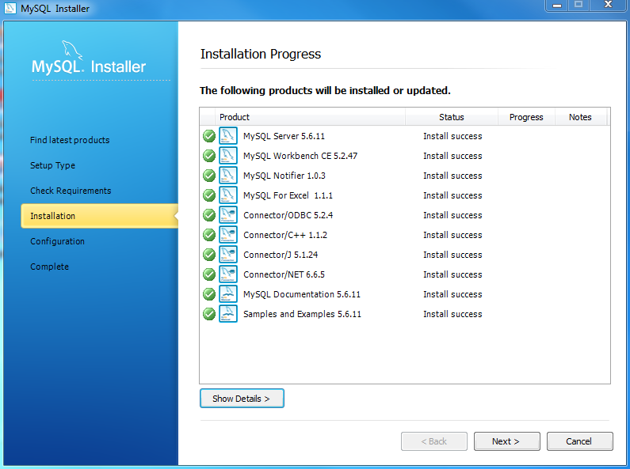

**Step 7(B) – Installation Progress: Complete Downloading. Click the Next button to continue**

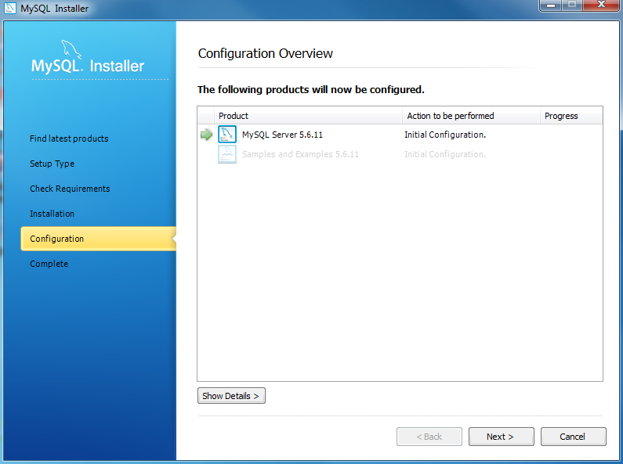

**Step 8 – Configuration Overview. Click the Next button to configure MySQL Database Server**

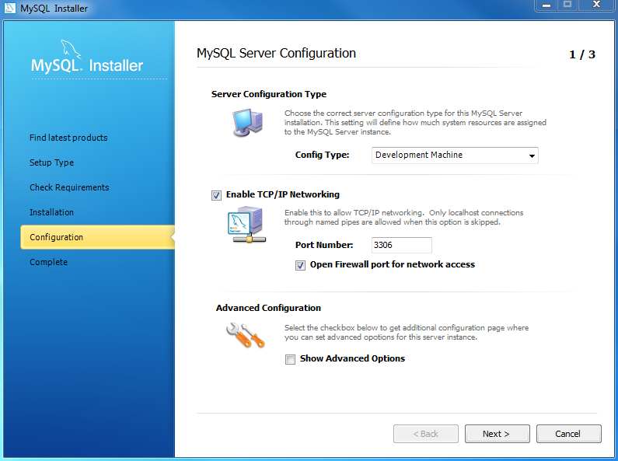

**Step 8.1 – MySQL Server Configuration: choose Config Type and MySQL port (3006 by default) and click Next button to continue.**

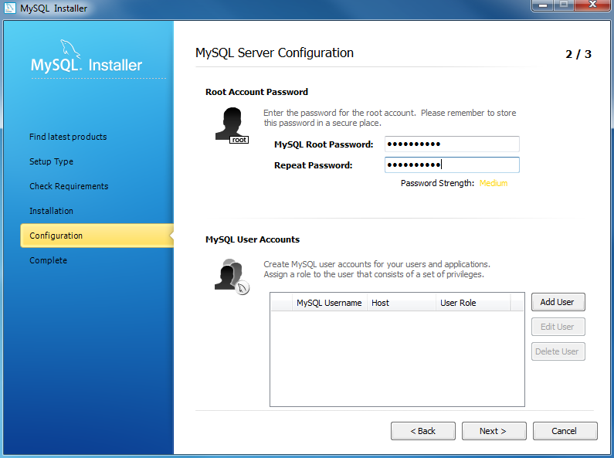

**Step 8.1 – MySQL Server Configuration: choose a password for the root account. Please note the password download and keep it securely if you are installing MySQL database server on a production server. If you want to add a more MySQL user, you can do it in this step.**

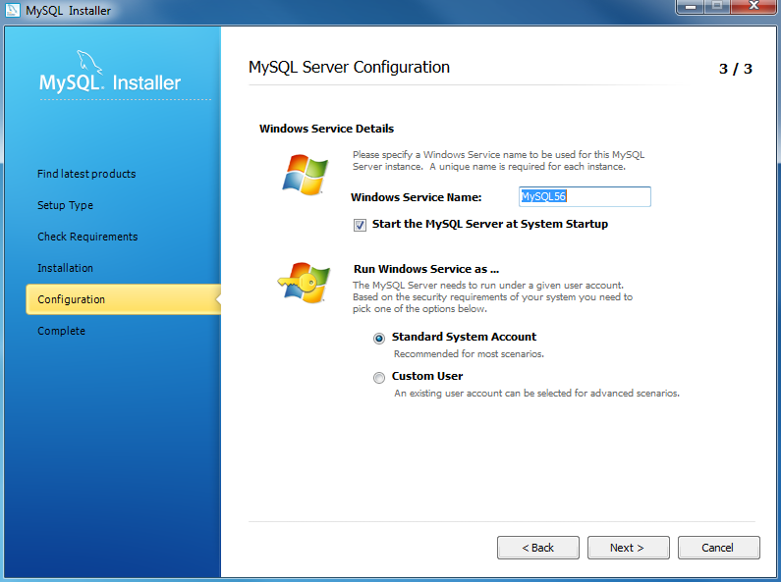

**Step 8.1 – MySQL Server Configuration: choose Windows service details including Windows Service Name and account type, then click Next button to continue.**

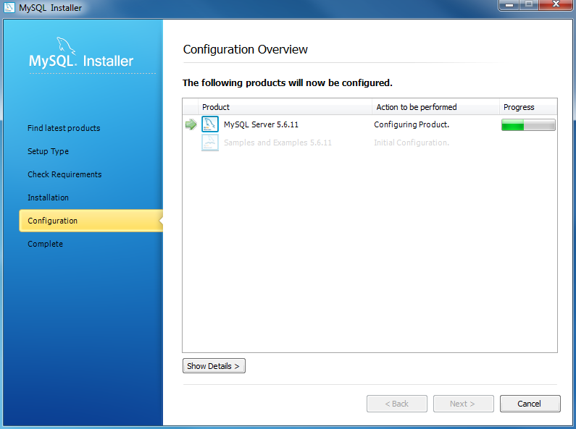

**Step 8.1 – MySQL Server Configuration – In Progress: MySQL Installer is configuring MySQL database server. Wait until it is done and click the Next button to continue.**

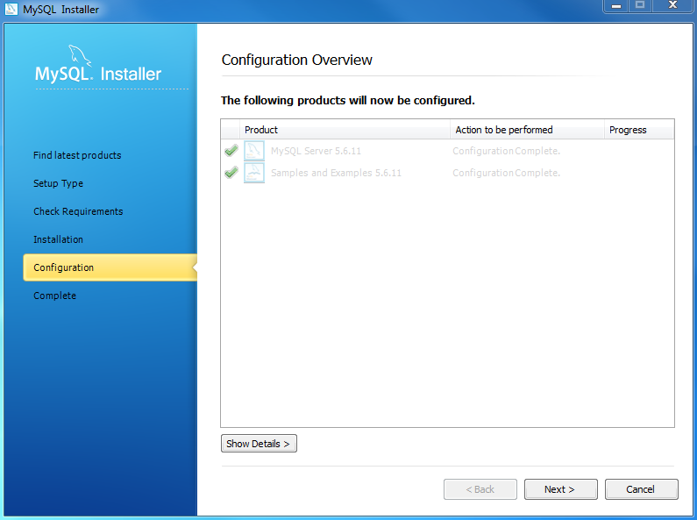

**Step 8.1 – MySQL Server Configuration – Done. Click the Next button to continue.**

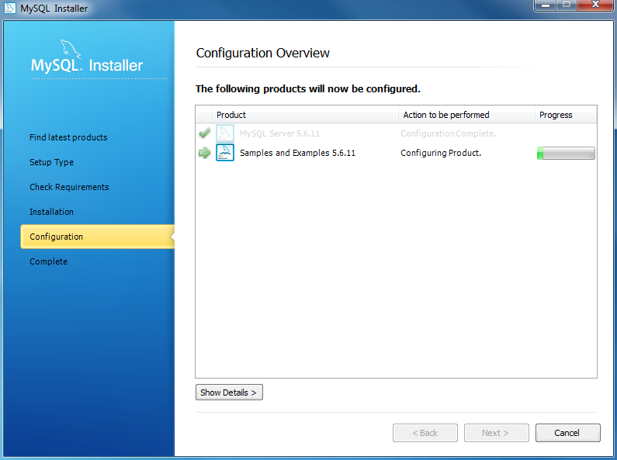

**Step 8.2 – Configuration Overview: MySQL Installer installs sample databases and sample models.**

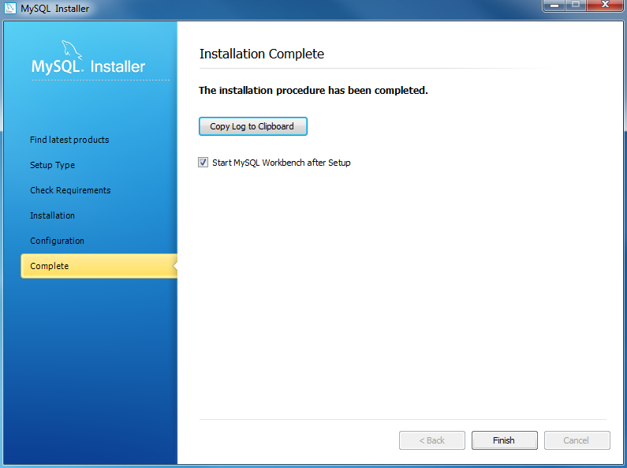

**Step 9 – Installation Completes: the installation completes. Click the Finish button to close the installation wizard and launch the MySQL Workbench.**

**Install MySQL Step : Linux configures MySQL :-**

**Step 1 — Installing MySQL:-**

**$ wget** [**https://dev.mysql.com/get/mysql57-community-release-el7-9.noarch.rpm**](https://dev.mysql.com/get/mysql57-community-release-el7-9.noarch.rpm)

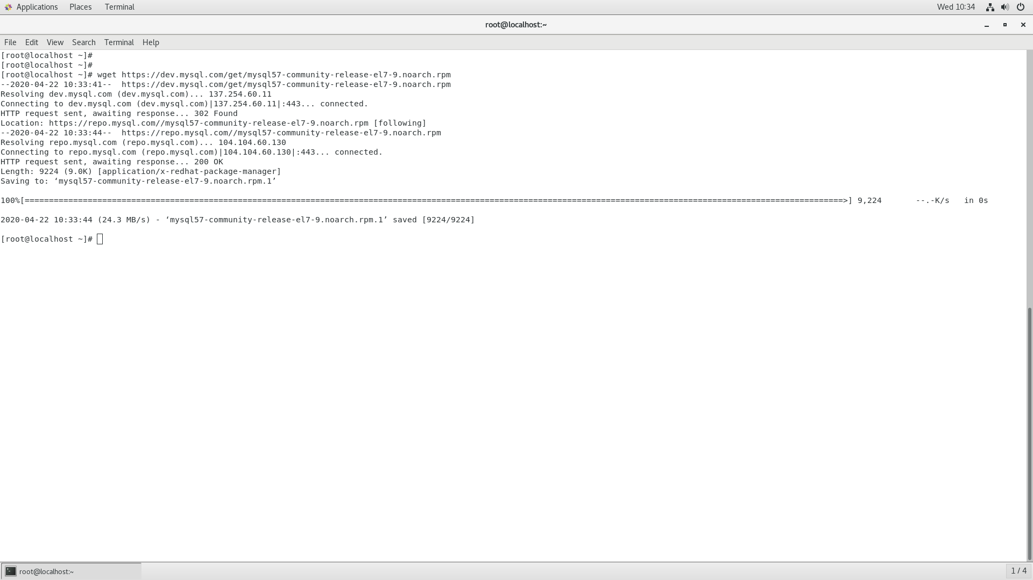

$ md5sum mysql57-community-release-el7-9.noarch.rpm

$ sudo rpm -ivh mysql57-community-release-el7-9.noarch.rpm

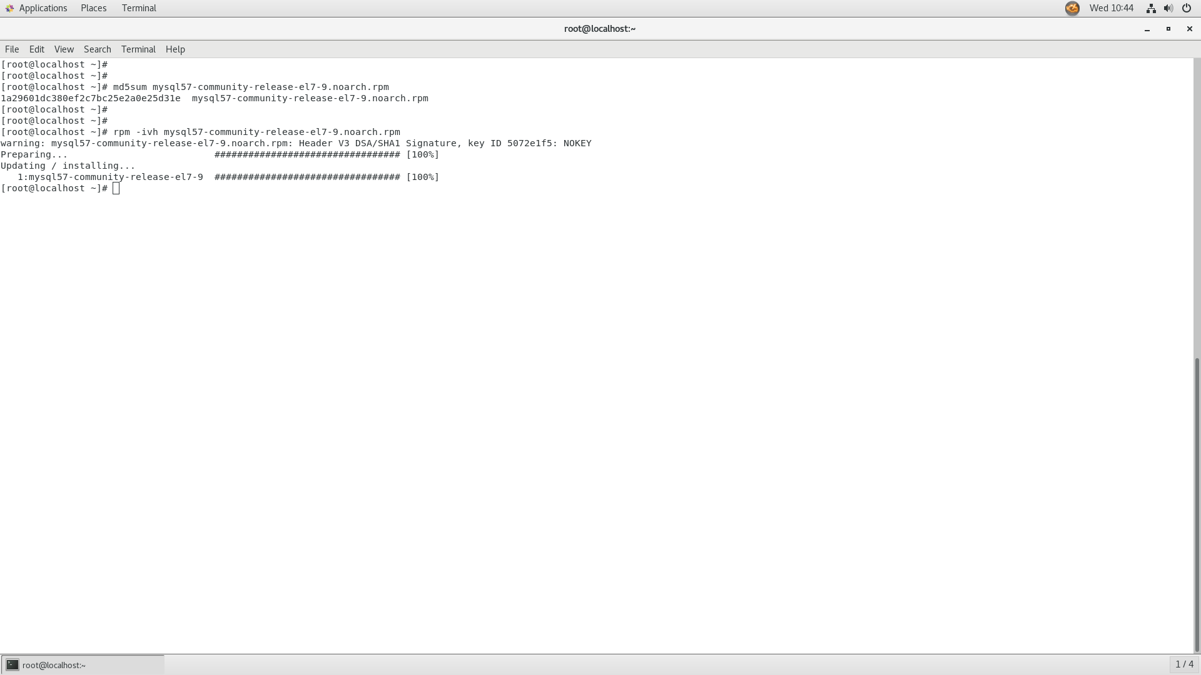

**$ sudo yum install mysql-server**

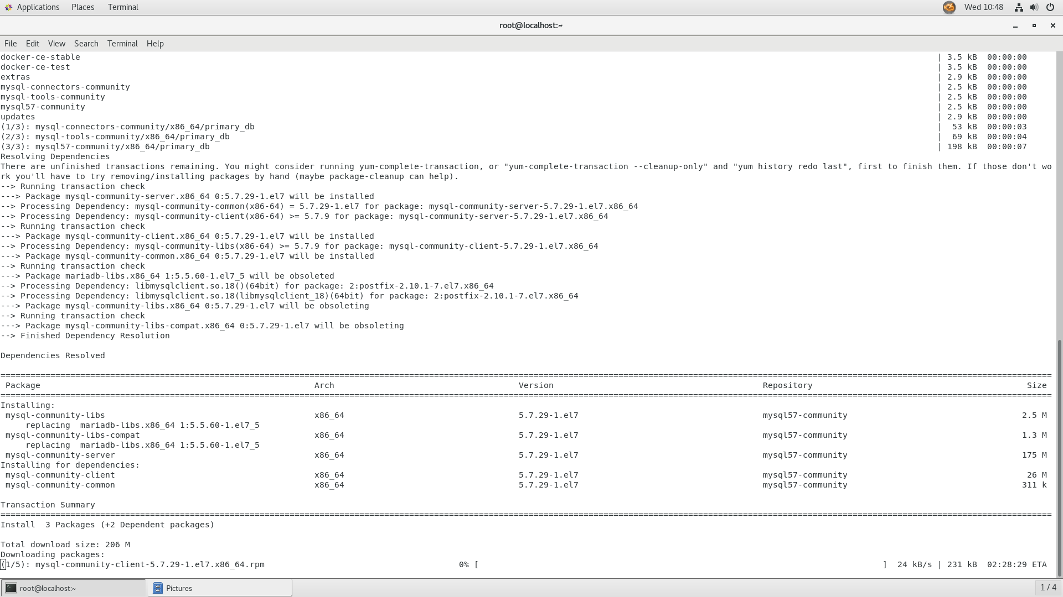

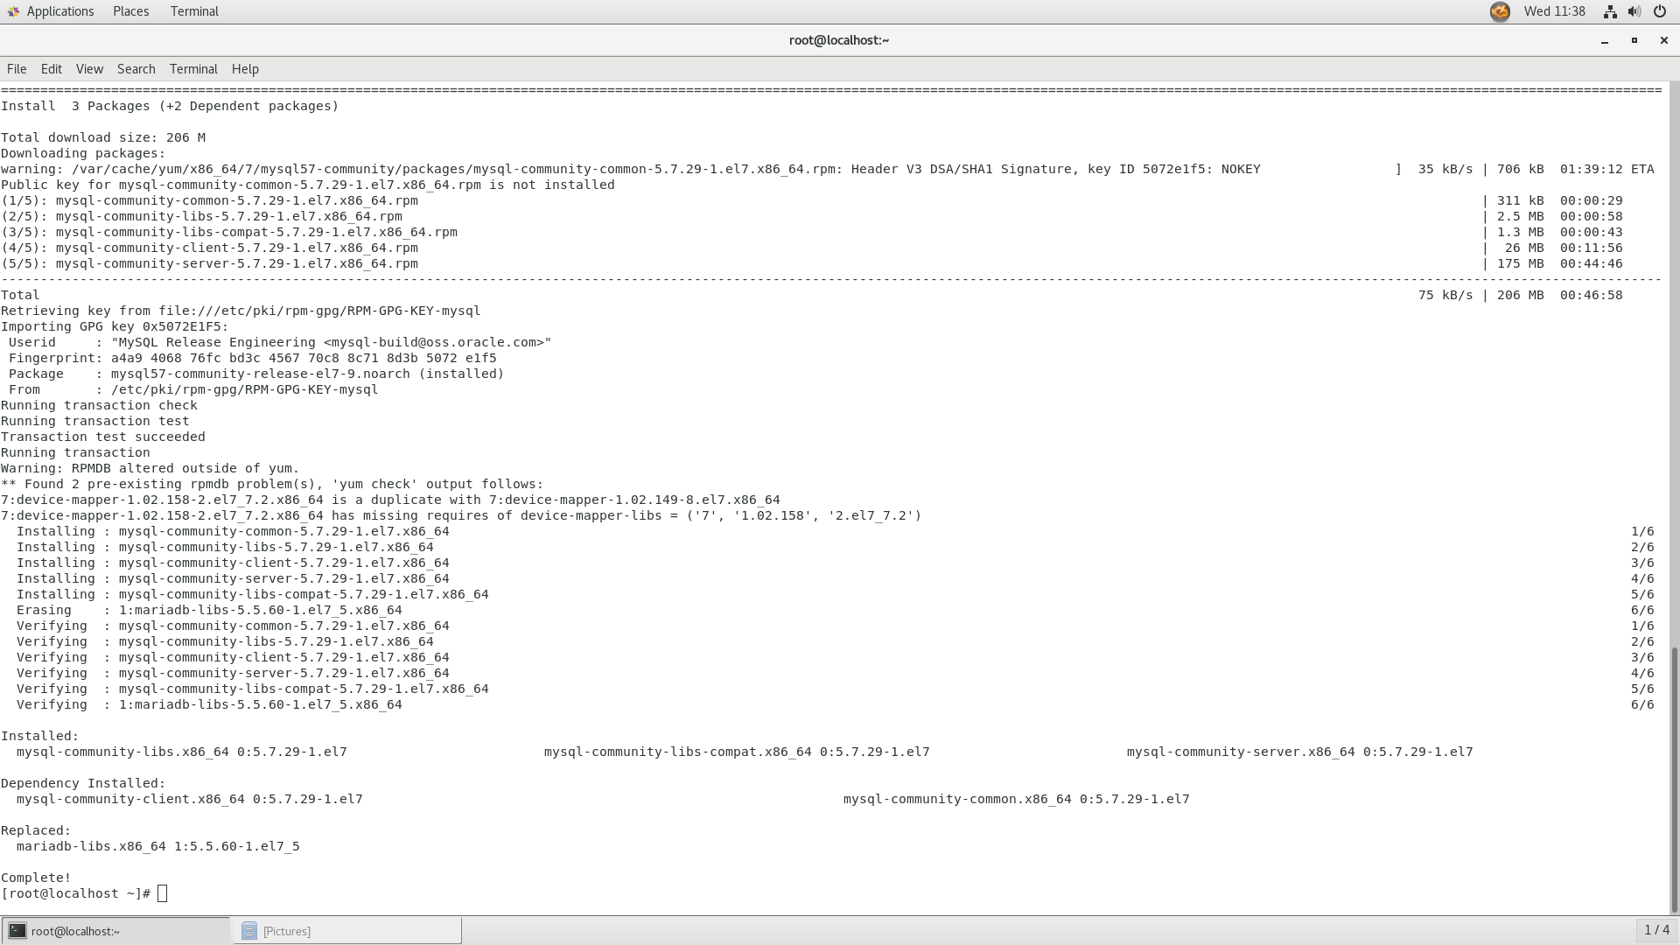

**Step 2 — Starting MySQL:-**

$ sudo systemctl start mysqld

$ sudo systemctl status mysqld

$ sudo grep 'temporary password' /var/log/mysqld.log

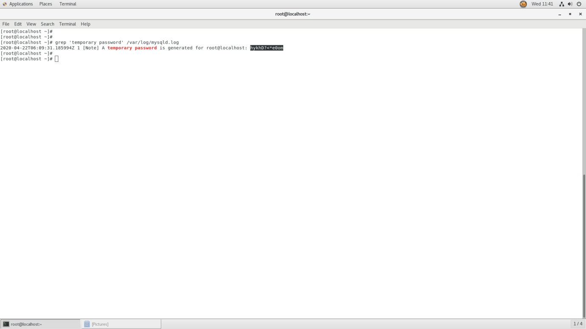

**Step 3 — Configuring MySQL:-**

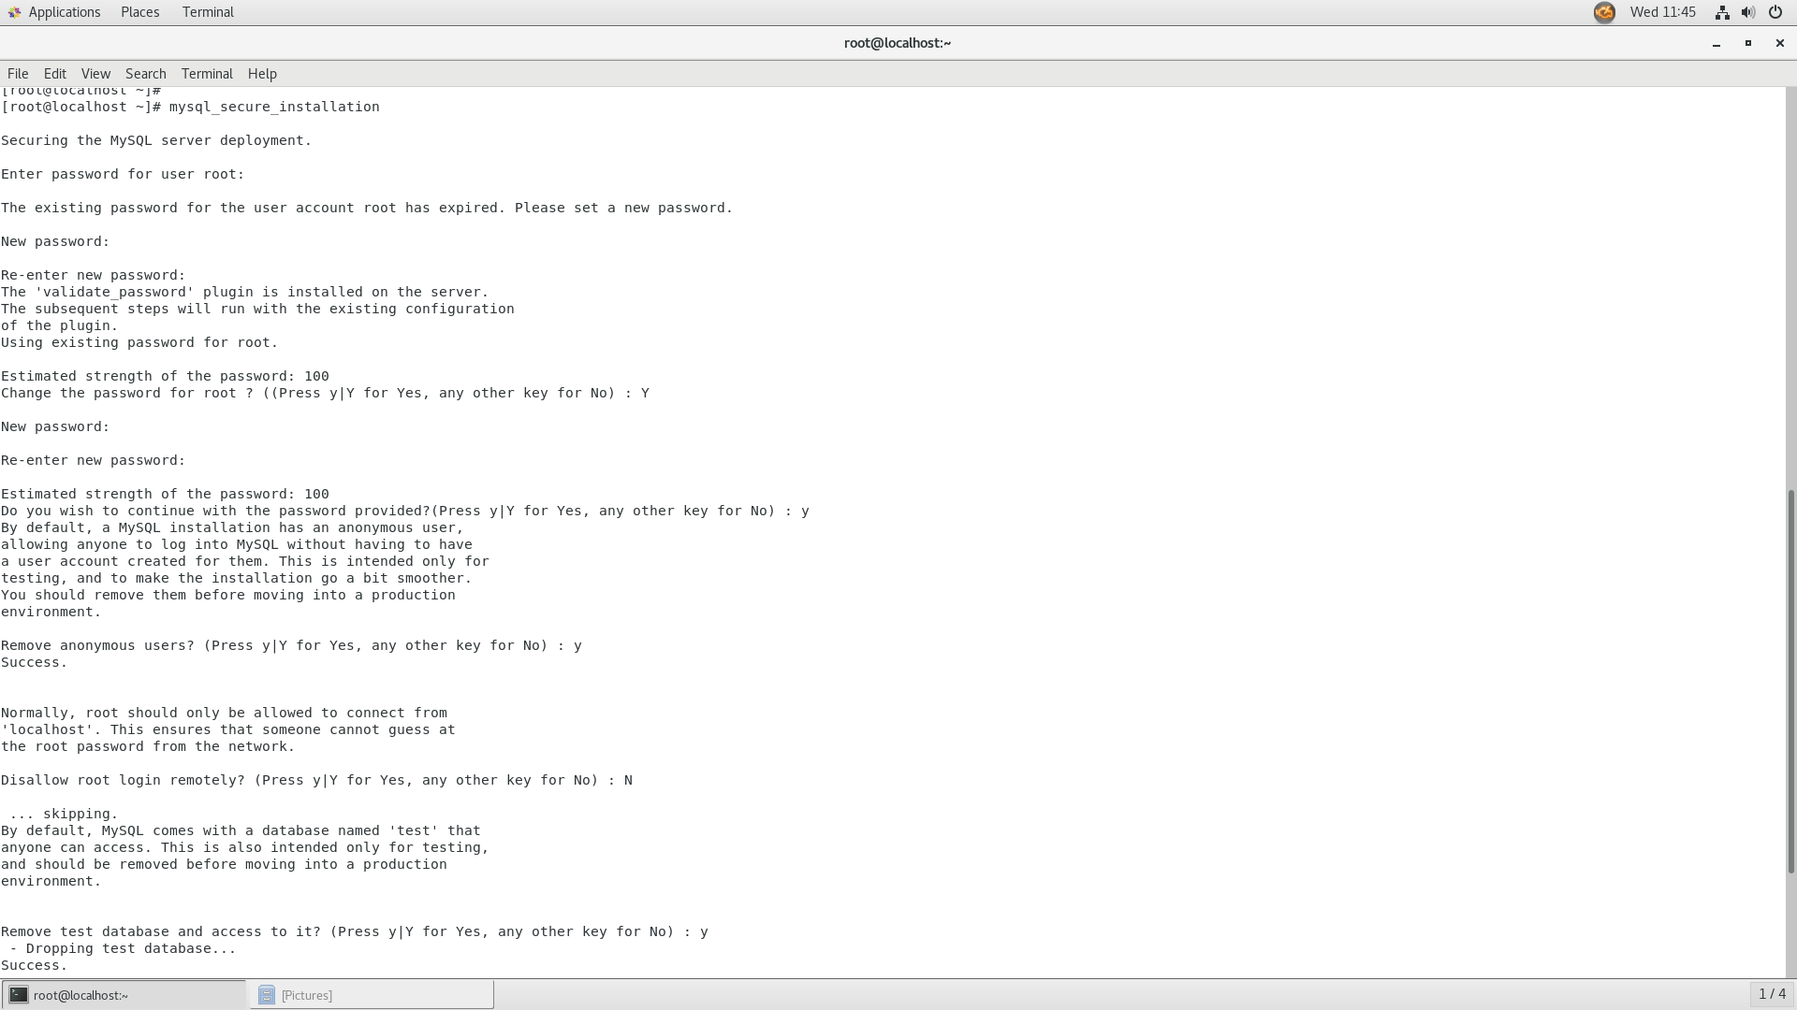

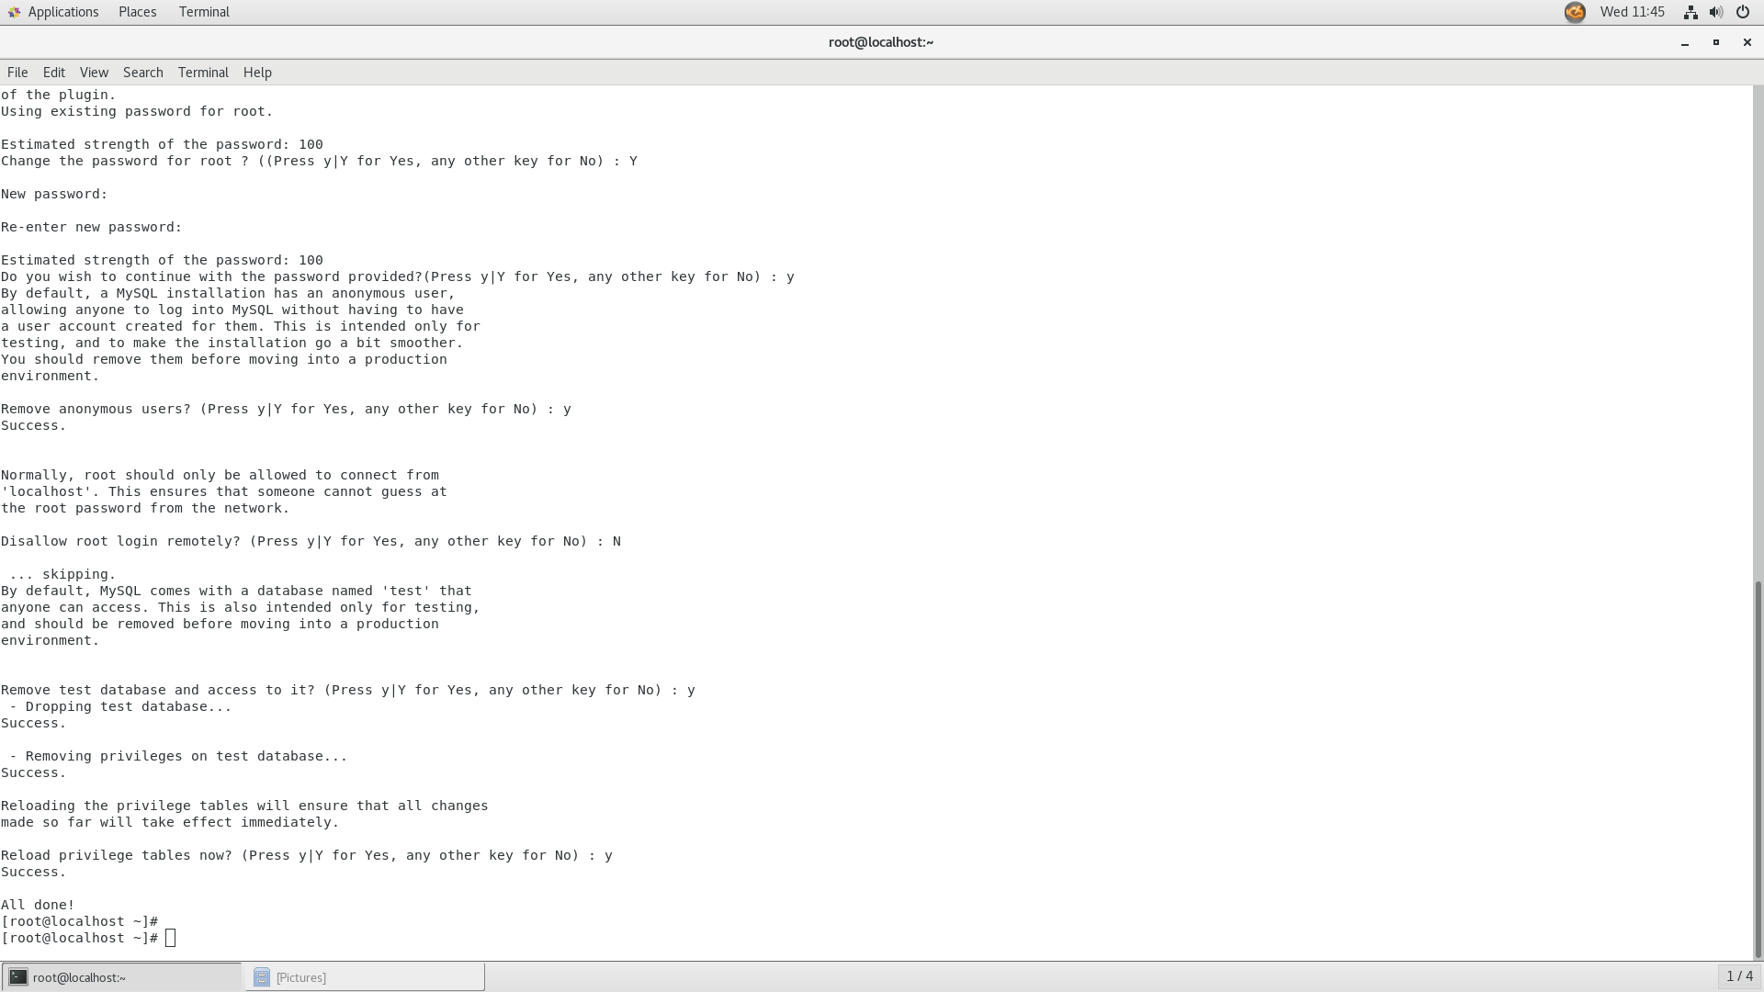

**Step 4 — Testing MySQL:-**

$ mysqladmin -u root -p

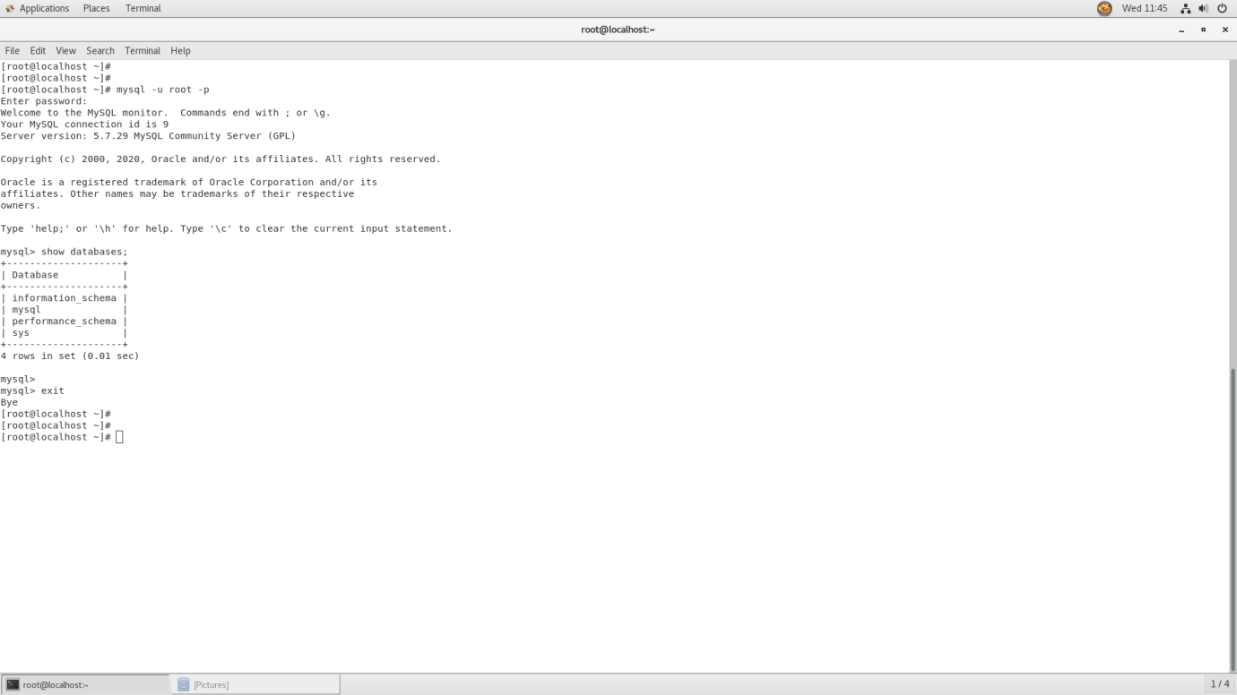

**Database manipulation with putty:-**

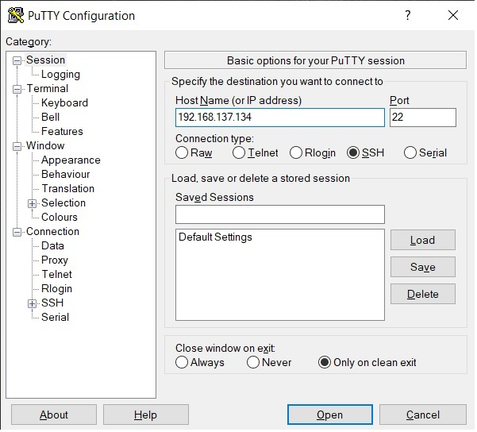

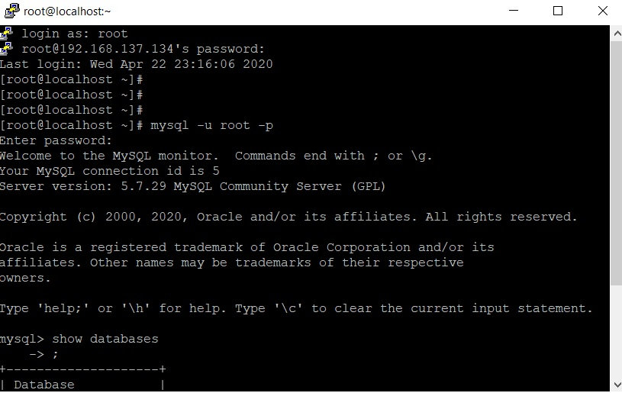

**Conclusion:**

Hence, we understood How to Install and Configure MySQL on Windows and Linux, Database Manipulation with putty.